**Interconnecting a Company and Its Branches Using IPv6 Summary Routes**

Student Version



Huawei Technologies Co., Ltd.

|  |
| --- |
| **Copyright © Huawei Technologies Co., Ltd. 2020. All rights reserved.**  No part of this document may be reproduced or transmitted in any form or by any means without prior written consent of Huawei Technologies Co., Ltd.  **Trademarks and Permissions**  HW_POS_RBG_Vertical-150ppi.png and other Huawei trademarks are trademarks of Huawei Technologies Co., Ltd.  All other trademarks and trade names mentioned in this document are the property of their respective holders.  **Notice**  The purchased products, services and features are stipulated by the contract made between Huawei and the customer. All or part of the products, services and features described in this document may not be within the purchase scope or the usage scope. Unless otherwise specified in the contract, all statements, information, and recommendations in this document are provided "AS IS" without warranties, guarantees or representations of any kind, either express or implied.  The information in this document is subject to change without notice. Every effort has been made in the preparation of this document to ensure accuracy of the contents, but all statements, information, and recommendations in this document do not constitute a warranty of any kind, express or implied. |

|  |  |
| --- | --- |
| Huawei Technologies Co., Ltd. | |
| Address: | Huawei Industrial Base  Bantian, Longgang  Shenzhen 518129  People's Republic of China |
| Website: | <https://e.huawei.com/> |

**Huawei Certification System**

Huawei Certification follows the "platform + ecosystem" development strategy, which is a new collaborative architecture of ICT infrastructure based on "Cloud-Pipe-Terminal". Huawei has set up a complete certification system consisting of three categories: ICT infrastructure certification, platform and service certification, and ICT vertical certification. It is the only certification system that covers all ICT technical fields in the industry. Huawei offers three levels of certification: Huawei Certified ICT Associate (HCIA), Huawei Certified ICT Professional (HCIP), and Huawei Certified ICT Expert (HCIE). Huawei Certification covers all ICT fields and adapts to the industry trend of ICT convergence. With its leading talent development system and certification standards, it is committed to fostering new ICT talent in the digital era, and building a sound ICT talent ecosystem.

Huawei Certified ICT Associate-Datacom (HCIA-Datacom) is designed for Huawei's frontline engineers and anyone who want to understand Huawei's datacom products and technologies. The HCIA-Datacom certification covers routing and switching principles, basic WLAN principles, network security basics, network management and O&M basics, SDN and programmability and automation basics.

The Huawei certification system introduces the industry, fosters innovation, and imparts cutting-edge datacom knowledge.

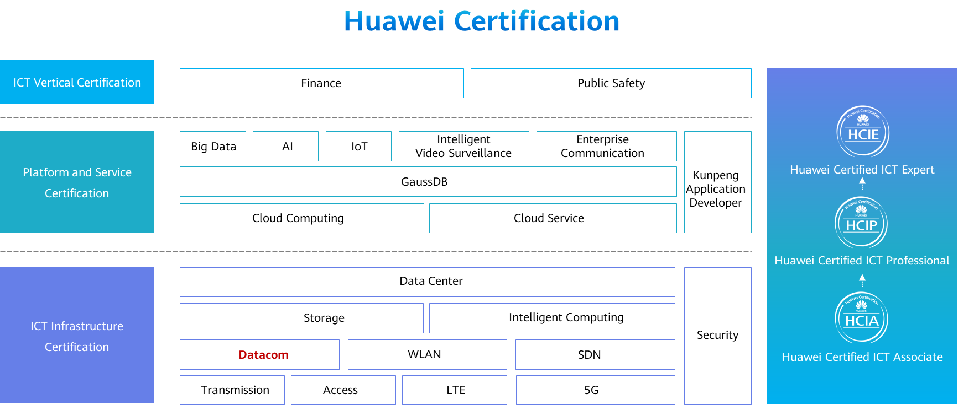

# Interconnecting a Company and Its Branches Using IPv6 Summary Routes

## Background

The company Jan16 has three offices: Beijing headquarters, Guangzhou branch, and Shanghai branch. The two branches are connected to the headquarters through routers. Routers R1, R2, and R3 reside in Beijing headquarters, Shanghai branch, and Guangzhou branch respectively, and IPv6 is enabled on the entire network. Beijing headquarters has three departments: the finance department, marketing department, and technology department. Each department needs to be assigned a separate VLAN. Configurations need to be performed on the routers so that all PCs can communicate with each other. The specific requirements are as follows:

Routers are connected through VPNs.

The headquarters and branches are connected using static routes.

The IP addresses and interfaces of PCs and routers are shown in the following topology section.

## Objectives

Upon completion of this task, you will be able to:

Learn how to manually configure IPv6 address on the routers.

Learn how to configure IPv6 static routes.

Learn how to configure IPv6 address on the PCs.

Learn how to configure IPv6 summary routes.

## Topology

Network topology

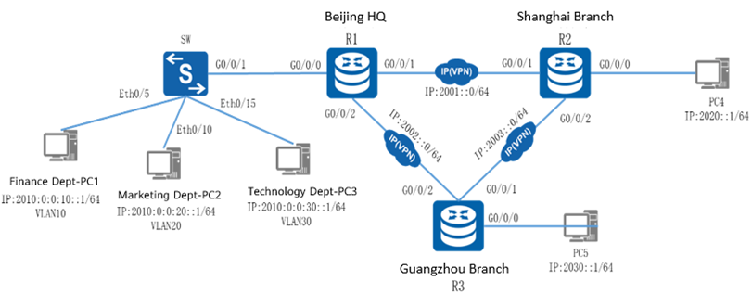

Shanghai and Guangzhou branches use network segments 2020::0/64 and 2030::0/64 respectively. To ease management, the finance department, marketing department, and technology department in the headquarters use network segments 2010:0:0:10::0/64, 2010:0:0:20::0, and 2010:0:0:30::0 respectively. Router-on-a-stick needs to be configured on R1 to implement intra-VLAN communication. Static routes need to be configured on the routers so that all PCs can communicate with each other. In addition, the three network segments in the headquarters are summarized using 2010::0/48 to simplify routing entries.

The IP address planning and interface planning can be referred in the appendix.

## Implementation

### Roadmap

1. Configure interfaces on the switch.
2. Configure the routers.
3. Configure static routes.
4. Configure an IP address for each PC.

### Procedure

Configure interfaces on the switch.

Create VLANs for each department and add ports to the VLANs.

Configure the routers.

Create three sub-interfaces on the Ethernet interface of R1, configure IP addresses and masks for the three sub-interfaces, use the sub-interfaces as the gateways of VLANs, and enable 802.1Q.

Run the ipv6 enable command to enable IPv6 on the Ethernet interface of each router.

#Configure R1.

#Configure R2.

#Configuration R3.

Configure static routes.

On R1, configure a static route with the network segment where PC2 resides as the destination network segment. That is, configure a static route with the destination IP address 2020:: and 64-bit mask. If R1 wants to send data to PC2, R1 first needs to send the data to its next-hop router R2. Therefore, the next-hop IP address of the configured static route is the IP address of the physical interface on the direct link between R2 and R1, namely, 2001::2.

#Configure a static route with the network segment where PC3 resides as the destination network segment.

#Similarly, on R2, configure two static routes with the network segments where PC1 and PC3 respectively reside as the destination network segments.

#Similarly, on R3, configure two static routes with the network segments where PC1 and PC2 respectively reside as the destination network segments.

Configure IP addresses for PCs.

Configure the IP addresses of PCs referred by the appendix.

* 1. **Verification**

Check the interface configuration.

Run the display ipv6 interface brief command on the routers to check the configuration.

#R1 configuration

[R1]display ipv6 interface brief

\*down: administratively down

(l): loopback

(s): spoofing

Interface Physical Protocol

GigabitEthernet0/0/0.10 up up

[IPv6 Address] 2010:0:0:10::1

GigabitEthernet0/0/0.20 up up

[IPv6 Address] 2010:0:0:20::1

GigabitEthernet0/0/0.30 up up

[IPv6 Address] 2010:0:0:30::1

GigabitEthernet0/0/1 up up

[IPv6 Address] 2001::1

GigabitEthernet0/0/2 up up

[IPv6 Address] 2002::1

#R2 configuration

[R2]display ipv6 interface brief

\*down: administratively down

(l): loopback

(s): spoofing

Interface Physical Protocol

GigabitEthernet0/0/0 up up

[IPv6 Address] 2020::1

GigabitEthernet0/0/1 up up

[IPv6 Address] 2001::2

GigabitEthernet0/0/2 up up

[IPv6 Address] 2003::2

#R3 configuration

[R3]display ipv6 interface brief

\*down: administratively down

(l): loopback

(s): spoofing

Interface Physical Protocol

GigabitEthernet0/0/0 up up

[IPv6 Address] 2030::1

GigabitEthernet0/0/1 up up

[IPv6 Address] 2003::3

GigabitEthernet0/0/2 up up

[IPv6 Address] 2002::3

Test the interoperability of PCs.

Run the ping command to test the internal communication of each PC.

#Ping PC2 from PC1.

[C:\~]$ ping 2010:0:0:20::10

Ping 2010:0:0:20::10: 32 data bytes, Press Ctrl\_C to break

From 2010:0:0:20::10: bytes=32 seq=1 hop limit=254 time=94 ms

From 2010:0:0:20::10: bytes=32 seq=2 hop limit=254 time=78 ms

From 2010:0:0:20::10: bytes=32 seq=3 hop limit=254 time=93 ms

From 2010:0:0:20::10: bytes=32 seq=4 hop limit=254 time=79 ms

From 2010:0:0:20::10: bytes=32 seq=5 hop limit=254 time=93 ms

--- 2010:0:0:20::10 ping statistics ---

5 packet(s) transmitted

5 packet(s) received

0.00% packet loss

round-trip min/avg/max = 78/87/94 ms

#Ping PC4 from PC1.

[C:\~]$ ping 2020::10

Ping 2020::10: 32 data bytes, Press Ctrl\_C to break

From 2020::10: bytes=32 seq=1 hop limit=253 time=31 ms

From 2020::10: bytes=32 seq=2 hop limit=253 time=16 ms

From 2020::10: bytes=32 seq=3 hop limit=253 time=32 ms

From 2020::10: bytes=32 seq=4 hop limit=253 time=47 ms

From 2020::10: bytes=32 seq=5 hop limit=253 time=31 ms

--- 2020::10 ping statistics ---

5 packet(s) transmitted

5 packet(s) received

0.00% packet loss

round-trip min/avg/max = 16/31/47 ms

The command output shows that the PCs can communicate with each other.

----**End**

## Appendix

IP address planning

| Device | Interface | IP Address |
| --- | --- | --- |
| R1 | G0/0/0.10 | 2010:0:0:10::1/64 |
| R1 | G0/0/0.20 | 2010:0:0:20::1/64 |
| R1 | G0/0/0.30 | 2010:0:0:30::1/64 |
| R1 | G0/0/1 | 2001::1/64 |
| R1 | G0/0/2 | 2002::1/64 |
| R2 | G0/0/0 | 2020::1/64 |
| R2 | G0/0/1 | 2001::2/64 |
| R2 | G0/0/2 | 2003::2/64 |
| R3 | G0/0/0 | 2030::1/64 |
| R3 | G0/0/1 | 2003::3/64 |
| R3 | G0/0/2 | 2002::3/64 |
| PC1 | E0/0/1 | 2010:0:0:10::10/64 |
| PC2 | E0/0/1 | 2010:0:0:20::10/64 |
| PC3 | E0/0/1 | 2010:0:0:30::10/64 |
| PC4 | E0/0/1 | 2020::10/64 |
| PC5 | E0/0/1 | 2030::10/64 |

Interface planning

| Local Device | Local Interface | Peer Device | Peer Interface |
| --- | --- | --- | --- |
| SW1 | Eth0/0/5 | PC1 | Eth0/0/1 |
| SW1 | Eth0/0/10 | PC2 | Eth0/0/1 |
| SW1 | Eth0/0/15 | PC3 | Eth0/0/1 |
| R1 | G0/0/0 | SW1 | G0/0/1 |
| R1 | G0/0/1 | R2 | G0/0/1 |
| R1 | G0/0/2 | R3 | G0/0/2 |
| R2 | G0/0/0 | PC4 | Eth0/0/1 |
| R2 | G0/0/1 | R1 | G0/0/2 |
| R2 | G0/0/2 | R3 | G0/0/2 |
| R3 | G0/0/0 | PC5 | Eth0/0/1 |
| R3 | G0/0/1 | R2 | G0/0/2 |
| R3 | G0/0/2 | R1 | G0/0/2 |
| PC1 | Eth0/0/1 | SW1 | Eth0/0/5 |
| PC2 | Eth0/0/1 | SW1 | Eth0/0/10 |
| PC3 | Eth0/0/1 | SW1 | Eth0/0/15 |
| PC4 | Eth0/0/1 | R2 | G0/0/0 |
| PC5 | Eth0/0/1 | R3 | G0/0/0 |

Route planning

| Router | Destination Network Segment | Next-Hop Address/Interface |
| --- | --- | --- |
| R1 | 2020::/64 | 2001::2 |
| R1 | 2030::/64 | 2002::3 |
| R2 | 2010::/48 | 2001::1 |
| R2 | 2030::/64 | 2003::3 |
| R3 | 2010::/48 | 2002::1 |
| R3 | 2020::/64 | 2003::2 |

----End